# Exercise 6. Exercise in Feature Matching

## Matching via Correlation

Here we match the corners between two images via correlation. We split the problem into the following tasks:

1. Write a function which extracts a (*2n + 1) x (2n + 1)* pixel patch from an image. This pitch shall be centered at a given point *x,y.*
2. Enhance the above function such that it returns a *(2n + 1) x (2n + 1)* array of zeros if *x,y* is not at least *n* pixels from the boarder of the image.
3. Write a function that calculates the cross-correlation between two given image patches.
4. Use the Harris corners extracted from House1.bmp and House2.bmp. Make a function that for a given corner in House1.bmp finds the best match in House2.bmp with the highest correlation.
5. For each feature in House1. Bmp find the best match in House2.bmp.
6. Do the reverse of task 5.
7. Extract the feature pairs which are each other’s best match
8. Illustrate the result

The first 3 tasks are implemented into one function.

|  |
| --- |
| function cormat = correlatiomatrix(im1, p1, im2, p2, w, dmax)    if mod(w, 2) == 0  error('Window size should be odd');  end    [rows1, npts1] = size(p1);  [rows2, npts2] = size(p2);    % Initialize correlation matrix values to -infinty  cormat = -ones(npts1,npts2)*Inf;    if (rows1 ~= 2 || rows2 ~= 2)  error('Feature points must be specified in 2xN arrays');  end    [im1rows, im1cols] = size(im1);  [im2rows, im2cols] = size(im2);    r = w; % 'radius' of correlation window    % For every feature point in the first image extract a window of data  % and correlate with a window corresponding to every feature point in  % the other image. Any feature point less than distance n from the  % boundary of an image is not considered.    % Find indices of points that are distance 'r' or greater from  % Q2. boundary on image1 and image2;  n1ind = find(p1(1,:)>r & p1(1,:)<im1rows+1-r & ...  p1(2,:)>r & p1(2,:)<im1cols+1-r);    n2ind = find(p2(1,:)>r & p2(1,:)<im2rows+1-r & ...  p2(2,:)>r & p2(2,:)<im2cols+1-r);    for n1 = n1ind  % Generate window in 1st image  w1 = im1(p1(1,n1)-r:p1(1,n1)+r, p1(2,n1)-r:p1(2,n1)+r);  % Pre-normalise w1 to a unit vector.  w1 = w1./sqrt(sum(sum(w1.*w1)));    % Identify the indices of points in p2 that we need to consider.  if dmax == inf  n2indmod = n2ind; % We have to consider all of n2ind    else % Compute distances from p1(:,n1) to all available p2.  p1pad = repmat(p1(:,n1),1,length(n2ind));  dists2 = sum((p1pad-p2(:,n2ind)).^2);  % Find indices of points in p2 that are within distance dmax of  % p1(:,n1)  n2indmod = n2ind(find(dists2 < dmax^2));  end    % Calculate normalised correlation measure. Note this gives  % significantly better matches than the unnormalised one.    for n2 = n2indmod  % Generate window in 2nd image  w2 = im2(p2(1,n2)-r:p2(1,n2)+r, p2(2,n2)-r:p2(2,n2)+r);  cormat(n1,n2) = sum(sum(w1.*w2))/sqrt(sum(sum(w2.*w2)));  end  end |

To proceed with matching via correlation, write another function:

|  |
| --- |
| function [m1, m2, p1ind, p2ind, cormat] = ...  matchbycorrelation(im1, p1, im2, p2, w, dmax)    if nargin == 5  dmax = Inf;  end    im1 = double(im1);  im2 = double(im2);    % Subtract image smoothed with an averaging filter of size wXw from  % each of the images. This compensates for brightness differences in  % each image. Doing it now allows faster correlation calculation.  im1 = im1 - filter2(fspecial('average',w),im1);  im2 = im2 - filter2(fspecial('average',w),im2);    % Generate correlation matrix  cormat = correlatiomatrix(im1, p1, im2, p2, w, dmax);  [corrows,corcols] = size(cormat);    % Find max along rows give strongest match in p2 for each p1  [mp2forp1, colp2forp1] = max(cormat,[],2);    % Find max down cols give strongest match in p1 for each p2  [mp1forp2, rowp1forp2] = max(cormat,[],1);    % Now find matches that were consistent in both directions  p1ind = zeros(1,length(p1)); % Arrays for storing matched indices  p2ind = zeros(1,length(p2));  indcount = 0;  for n = 1:corrows  if rowp1forp2(colp2forp1(n)) == n % consistent both ways  indcount = indcount + 1;  p1ind(indcount) = n;  p2ind(indcount) = colp2forp1(n);  end  end    % Trim arrays of indices of matched points  p1ind = p1ind(1:indcount);  p2ind = p2ind(1:indcount);    % Extract matched points from original arrays  m1 = p1(:,p1ind);  m2 = p2(:,p2ind); |

The arguments *p1,p2* are the coordinates of corner detection on House1.bmp and House2.bmp respectively.

|  |
| --- |
| function [r, c] = corner_detection( im )  radius = 1;  sigma = 2;  k = 0.04;  t=sigma*sigma;  x=-3*ceil(sigma):3*ceil(sigma);  g=exp(-x.*x./(2*t))/sqrt(2*pi*t);  gx=(-x/t).*exp(-x.*x./(2*t))/sqrt(2*pi*t);  Ix= filter2(gx,im,'same');  Ix= filter2(g',Ix,'same');  Iy= filter2(g,im,'same');  Iy= filter2(gx',Iy,'same');    Ix2 = filter2(g, Ix.^2, 'same');  Iy2 = filter2(g, Iy.^2, 'same');  Ixy = filter2(g, Ix.*Iy, 'same');  cim = (Ix2.*Iy2 - Ixy.^2) - k*(Ix2 + Iy2).^2;  maxcim = max(max(cim));  thresh = 0.08*maxcim;  % B=ORDFILT2(A,ORDER,DOMAIN) replaces each element in A by the  % ORDER-th element in the sorted set of neighbors specified by  % the nonzero elements in DOMAIN.  sze = 2*radius+1;  mx = ordfilt2(cim,sze^2,ones(sze));  cim = (cim == mx) & (cim > thresh);  [r, c] = find(cim);    figure, imagesc(im), axis image, colormap(gray), hold on  plot(c,r,'b*'), title('corners detected');      end |

|  |
| --- |
| clear all  clc  close all    I = imread('House1.bmp');  I2 = imread('House2.bmp');  figure(1)  imshow(I);  figure(2)  imshow(I2);  [r1, c1] = corner_detection(I);  [r2, c2] = corner_detection(I2);  p1 = [r1 c1]';  p2 = [r2 c2]';  n = 8;  r = 2*n + 1;  dmax = inf;  [**m1, m2**, p1ind, p2ind, cormat] = matchbycorrelation(I, p1, I2, p2, r, dmax);  **% matching points m1,m2**  figure(5)  showMatchedFeatures(I,I2,m1',m2','montage','Parent',axes); |

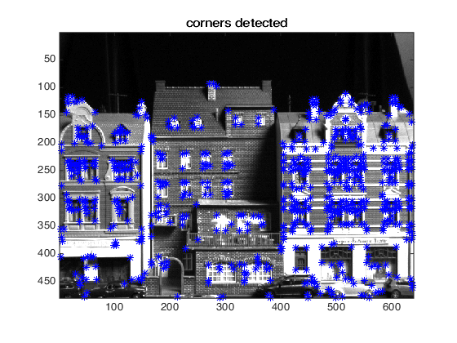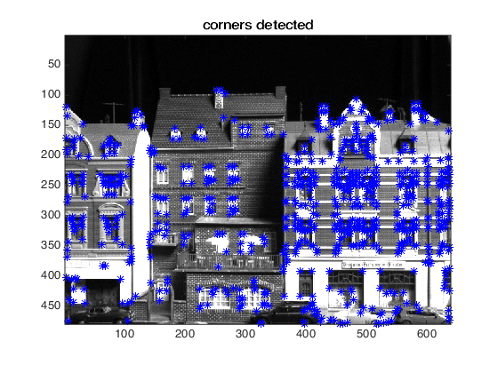

Figure 1. Detected corners of House1.bmp Figure 2. Detected corners of House2.bmp

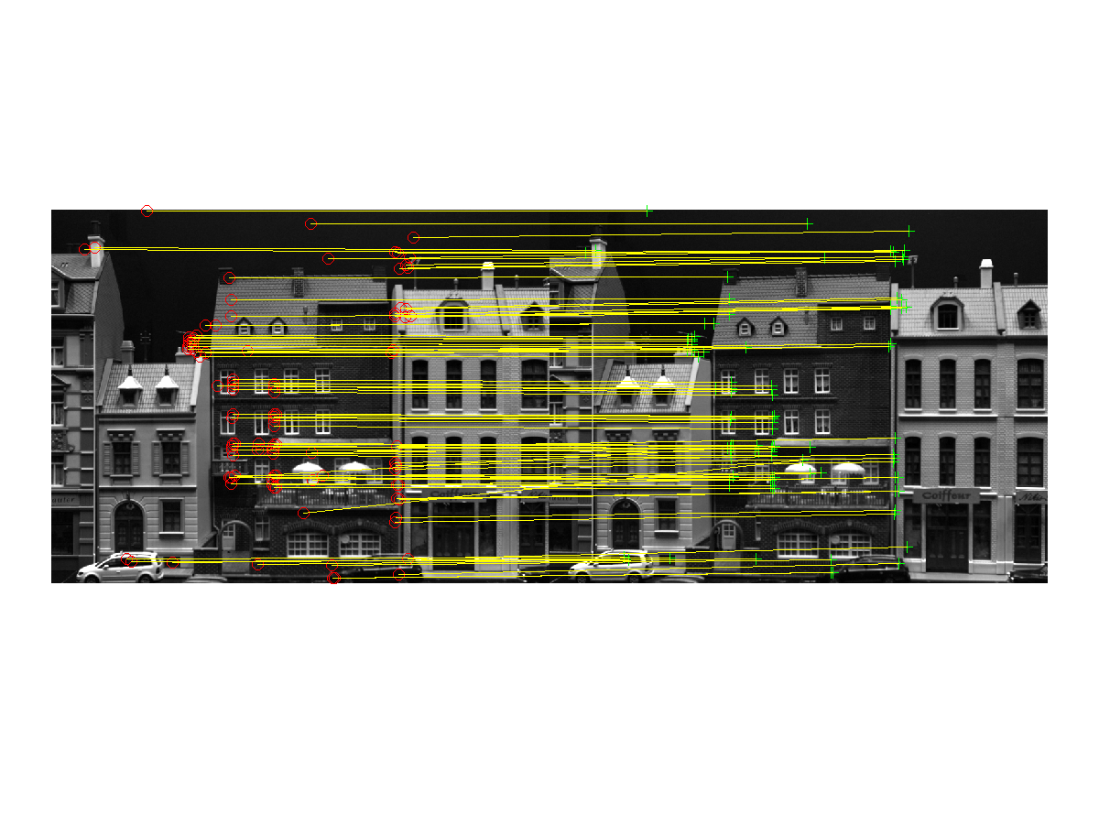

Figure 3. Matching the corners of two images 127.

## Modifying the problem

To investigate how **correlation based feature** matching **degrades** with a harder problem, you should here gradually modify House2.bmp and rerun your matching algorithm from above. You should modify the image via a homography, which you can do via the following code:

|  |
| --- |
| a = 20*pi/180;  %a = 45*pi/180;  %a = 90*pi/180;  s = sin(a);  c = cos(a);  H = [c s 0; -s c 0; 0 0 1];  Tr = maketform('projective', H);  WarpIm = imtransform(I2, Tr); |
| Image is rotated by 20 degrees. |

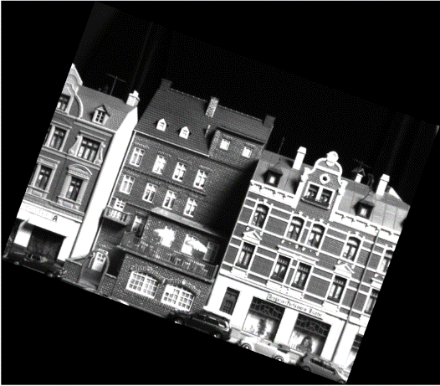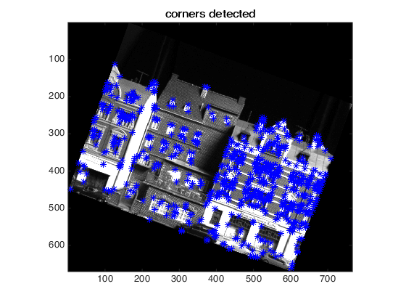Figure 4. Warped Image, House2.bmp Figure 5. Detected corners of warped image, House2.bmp

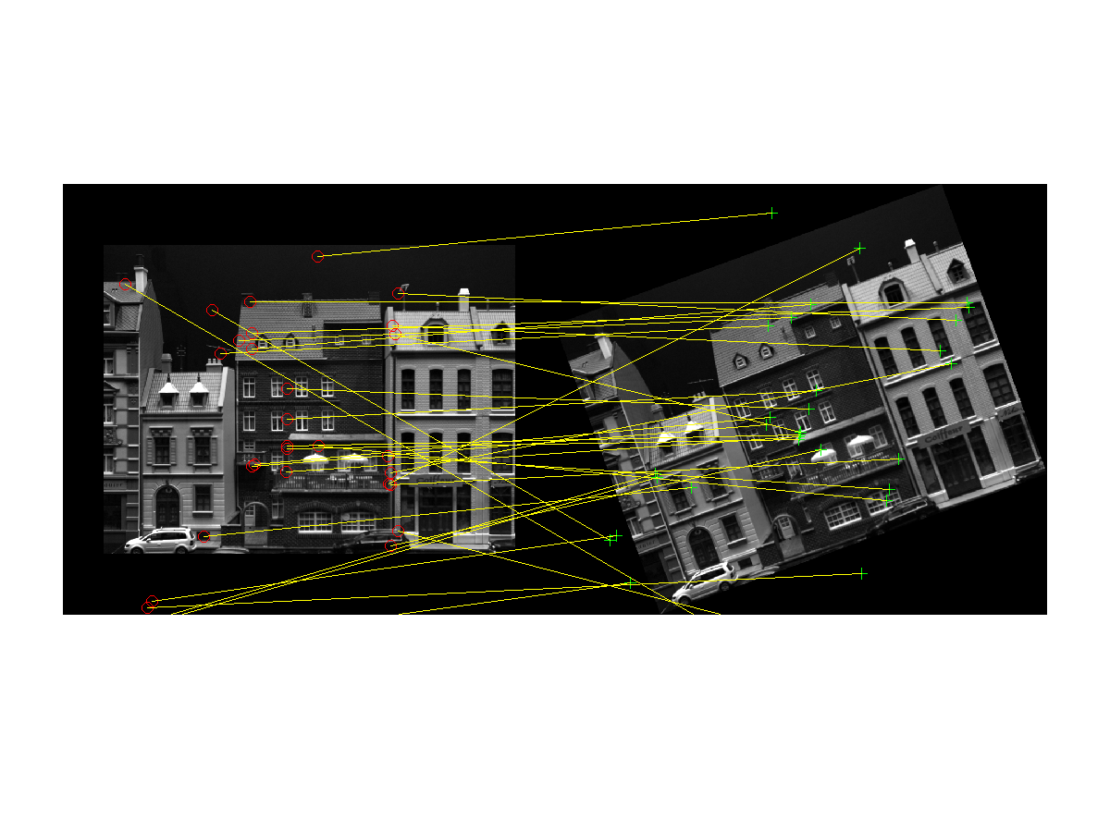

Figure 6. Matching corners of two images. The second image is rotated by 20 degrees. 31

The performance is decreased if the second image is rotated. For bigger rotations of the image, the performance of matching corners is decreasing, but the decreasing is not linear. When rotating 170, the matching points are 37.

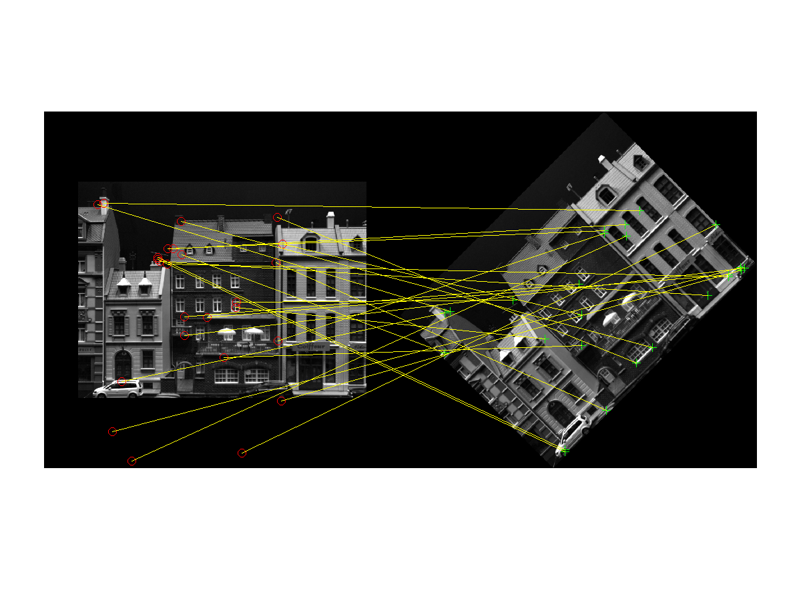

Figure 7. Matching corners of two images. The second image is rotated by 45 degrees. 25

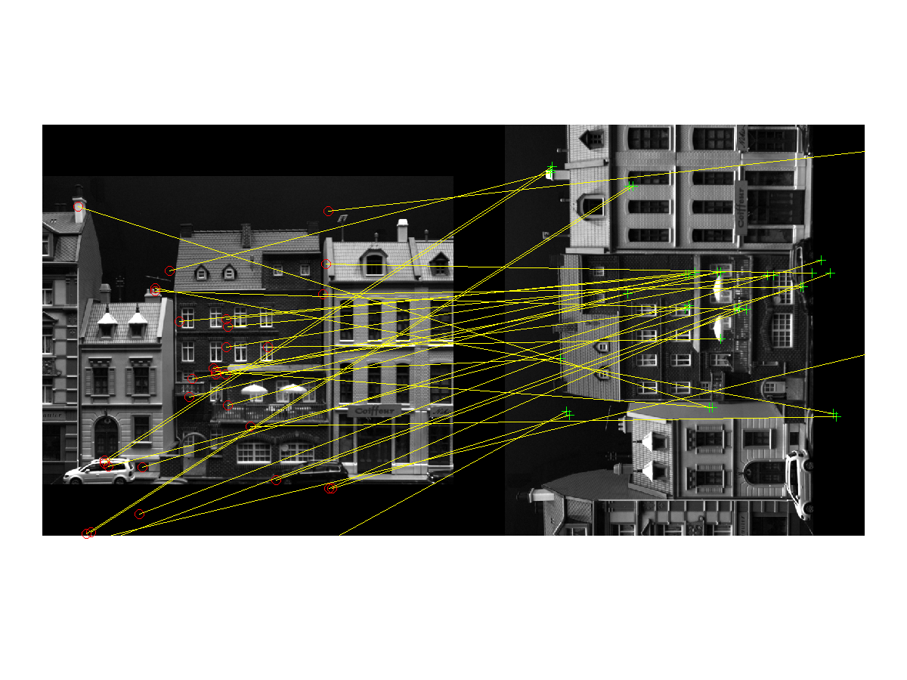

Figure 8. Matching corners of two images. The second image is rotated by 90 degrees. 33

Let’s try with a different homography:

s = 0.1;

H = [1 0 0; s 1 0; 0 0 1];

Here we have the value *s,* which when takes different values,the image changes according to this value.

After selecting the values 0.1, 0.5 and 1, we get the following results:

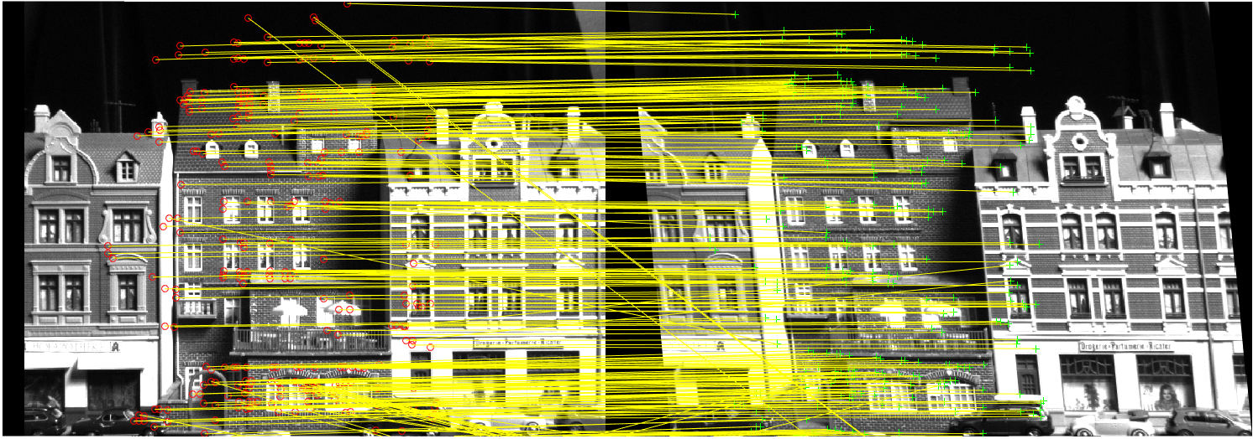

Figure 9. Matching corners. s = 0.1, 100 matching points

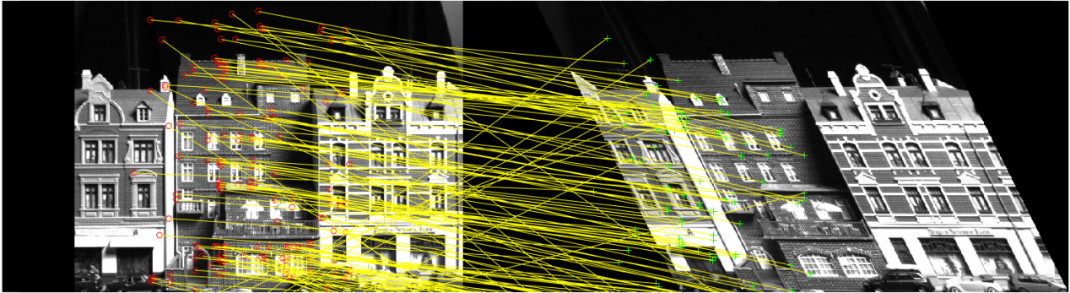

Figure 10. Matching corners, s = 0.5, 21 matching points

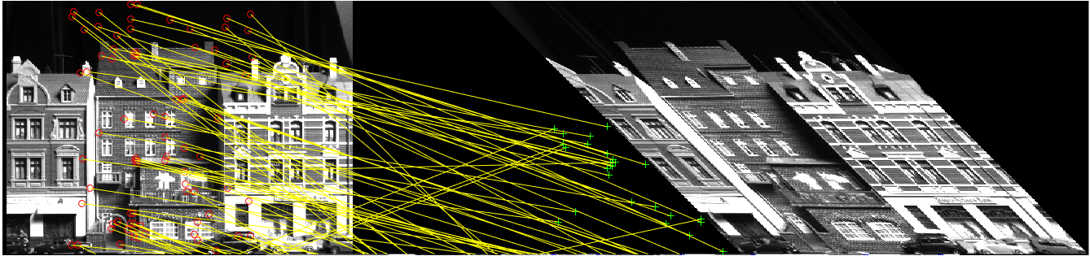

Figure 11. Matching corners, s = 1, 13 matching points

We see that with different values of *s,* the second image reclines accordingly. The matching points decreasing seemingly linear as s increases.

4 Using Epipolar Geometry

|  |
| --- |
| t_cross = CrossOp(T2);  F = pinv(A)' * t_cross * R2 * A^-1;  d = sampsonFun(F,p1,p2)  quantile(d,10)  for i= 1:size(d,2)  if d(i) >= 45  p1(:,i)=0;  p2(:,i)=0;  else  pf1(:,i) = p1(:,i);  pf2(:,i) = p2(:,i);  end  end  np1 = nonzeros(pf1);  np2 = nonzeros(pf2);  s = size(np1,1)/2  pp1 = reshape(np1,2,s);  pp2 = reshape(np2,2,s);  %%  figure(4)  showMatchedFeatures(I,I2,pp1',pp2','montage'); |
|  |

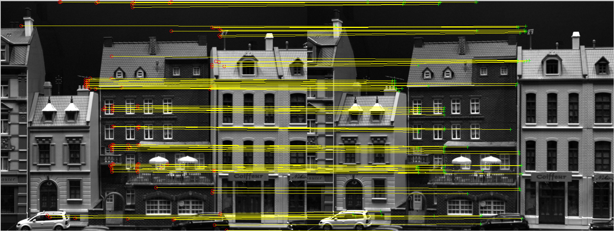

Matching points 106.

3 Matching with SIFT

Without any deformation, matching points are 879.

[fa, da] = vl_sift(single((im1)));

[fb, db] = vl_sift(single((I2)));

[matches, scores] = vl_ubcmatch(da, db); %descriptor

nMatch=size(matches,2);

X1 = fa(1:2,matches(1,:));% matching points

X2 = fb(1:2,matches(2,:));

figure(1)

showMatchedFeatures(im1,I2,X1',X2','montage');

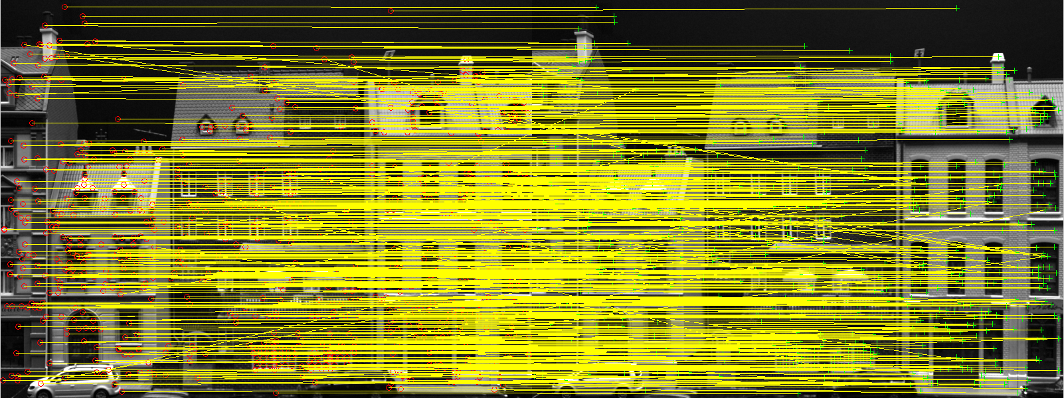

**s=0.1,**  matching points 851

H=[1 0 0; s 1 0; 0 0 1];

%Note That H has to be transposed here if column vectors are used for points

Tr=maketform('projective',H');

figure(3)

I2=imtransform(im2,Tr);

imshow(I2);

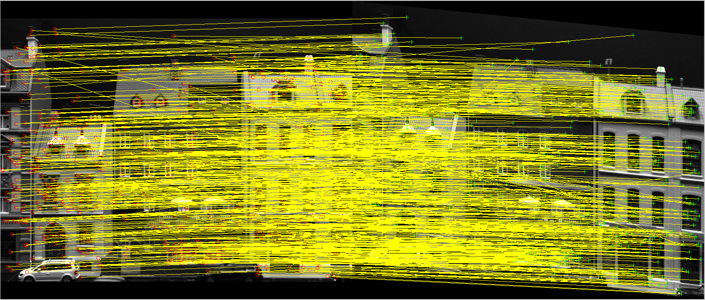

**s=0.5; matching points 323**

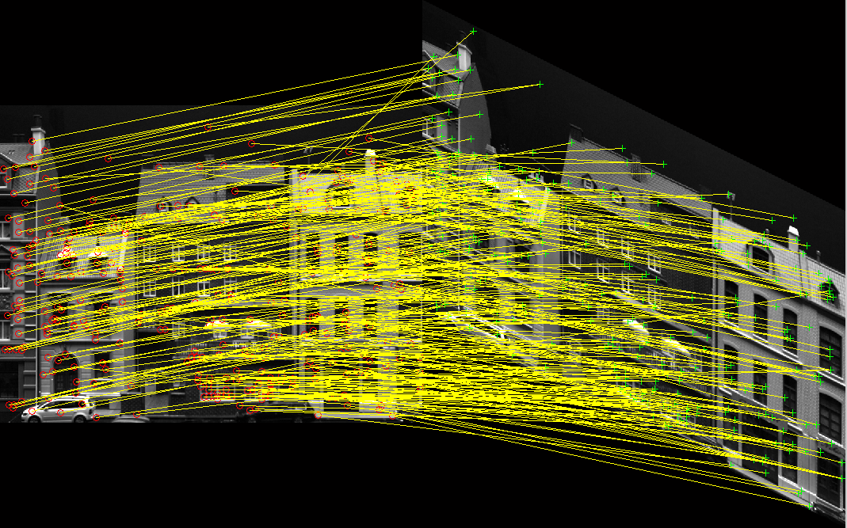

**s=1; matching points 76**

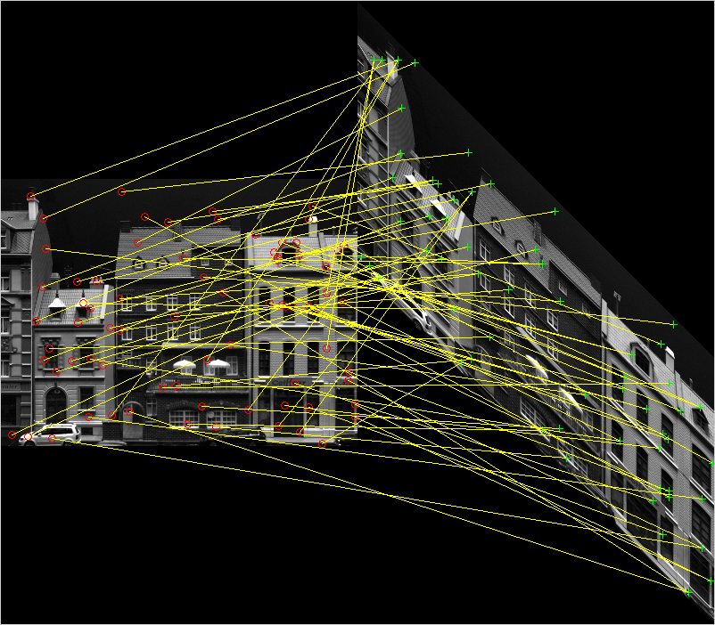

# 4 Using Epipolar Geometry

In the exercise previous exercise ”Exercise in the Camera Model”, you computed the fundamentalmatrix between the two of the images from TwoImageData.mat. Repeat the experiments fromabove - omit the image warping. No enhance your feature matcher by only allowing matches whichare consistent with the epipolar geometry.

- What is the effect of using epipolar? Check if the correspondent points fall on the epipolar lines. Hint: Use the sampsons distance equation (2.40) in the lecture notes to compute if two **features are consistent** with the epipolar geometry. Set a reasonable noise level yourself.

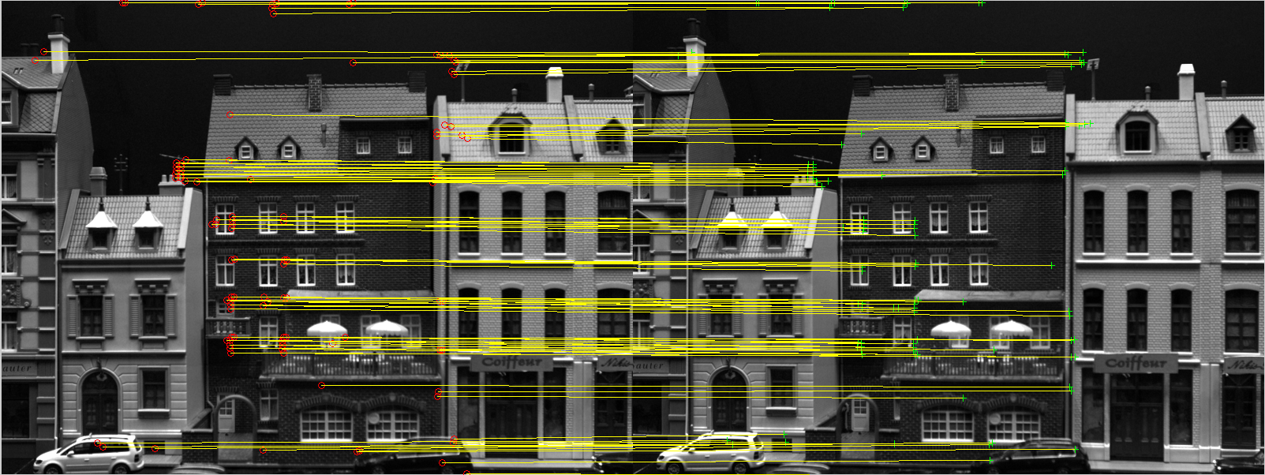

[r1, c1] = corner_detection(I);

[r2, c2] = corner_detection(I2);

p1 = [r1 c1]';

p2 = [r2 c2]';

length = min(length(p1),length(p2));

p1=p1(:,1:length);

p2=p2(:,1:length);

pp1 = [p1;ones(1,length)];

pp2 = [p2;ones(1,length)];

%%

t_cross = CrossOp(T2);

F = pinv(A)' * t_cross * R2 * A^-1;

d = sampsonFun(F,p1,p2)

thr = quantile(d,10)

sigma=3;

thresh = 5.99 * sigma^2; %% threshold at ca. 70% quantile

for i= 1:size(d,2)

if d(i) >= thresh

p1(:,i)=0;

p2(:,i)=0;

else

pf1(:,i) = p1(:,i);

pf2(:,i) = p2(:,i);

end

end

np1 = nonzeros(pf1);

np2 = nonzeros(pf2);

s = size(np1,1)/2

pp1 = reshape(np1,2,s);

pp2 = reshape(np2,2,s);

